AP Calc AB Name: _______________

______________ _____________

WS Assessment

Target 11:

Linear approximation, related rate, L’hospital rule

**I can:**

* Approximate a value on a curve using the equation of tangent line
* Calculate related rates in applied contexts
* Determined limits of functions that result in indeterminate form

Unit 4: Contextual Applications of Differentiation

HW Target 11

Unit 4 Progress Check FRQ A and B

“**If you’re a very tiny bug crawling on a function’s graph, you may think the graph is a straight line, much as people once thought our earth was flat. This means that near the point of tangency, the tangent line is often a very good approximation to the function...”**

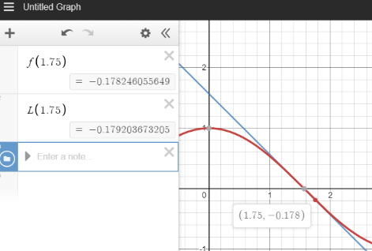**Linearization** of function f(x) at x = a is L(x) = f '(a)(x – a) + f(a)

Find the linearization of f(x) = cos x at x = pi/2 and use it approximate cos(1.75). Show graph for stamp

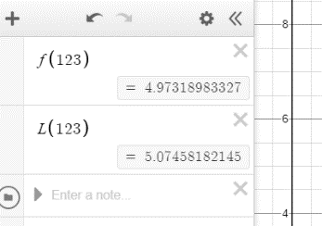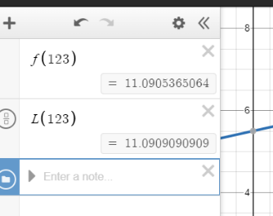Approximating $\sqrt{123}$ and $\sqrt[3]{123}$. Hint what curve in use at what point. Show graphs for stamps

Let *f*  be a function such that its slope is given by dy/dx = .5x − .25y2. The graph of *f* passes through the point (1,−2) and is concave up on the interval 1 < x <1.5 Let k be the approximation for *f*(1.3) found by using the locally linear approximation of *f* at x = 1. Find the value of k and determine if it is overestimate or underestimate.

Find the linearization of the function f(x) = ex at the point near zero

A pizza restaurant sells an average of 80 pizzas per day at its usual price of $12.95. It experiments with sales and coupons for dollars off the usual price, and finds that the number of pizzas sold when the price decreases by 2 dollars is 135. It estimates that the number of pizzas sold when the price goes down by x dollars is modeled by the function 50 ln(x + 1) + 80. Use linear approximation to find the change in the number of pizzas sold when the price drops from $12.95 to $9.95.

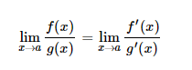**L' Hospital Rule**:

For indeterminate form 0/0 and ∞ / ∞

For other indeterminate form (∞)(0) ; ∞ - ∞ ; 1∞ , 00, ∞0 🡪 convert first

Check form then find limit of the following

$\lim_{x→2}{\frac{x-2}{x^{2}-4}}$ $\lim_{x→∞}{\frac{2x+7}{{3x}^{2}-5}}$ $\lim_{x→1}{\frac{5x^{4}-{4x}^{2}-1}{{10-x-9x}^{2}}}$

$\lim_{x→0}{\frac{\sqrt{1+x}-1-x/2}{x^{2}}}$ $\lim_{x→0}{\frac{ln⁡(x)}{2\sqrt{x}}}$ $\lim_{x→{π/2}^{-}}{\frac{sec⁡(x)}{1+tan⁡(x)}}$

You may need to convert it. Recall theorem: ln ($\lim_{x→c}{f(x))= }\lim_{x→c} ln⁡(f\left(x\right))$

$\lim_{x→0}{\sqrt{x}∙ln⁡(x)}$ $\underset{x→0}{lim⁡}x^{x}$ $\underset{x→0}{lim⁡}x^{sin⁡(x)}$

**Related Rate**

To solve related rates problems, you need a strategy that always works. Related rates problems always can be recognized by the words “increasing, decreasing, growing, shrinking, changing.” Follow these guidelines in solving a related rates problem.

* Make a sketch. Label all sides in terms of variables even if you are given the actual values of the sides.
* You will make a table of variables. The table will contain two types of variables - variables that are constants and variables that are changing. Variables that never change go into the constant column. Variables that are a given value only at a certain point in time go into the changing column. Rates (recognized by “increasing”, “decreasing”, etc.) are derivatives with respect to time and can go in either column.
* Find an equation which ties your variables together. If it an area problem, you need an area equation. If it is a right triangle, the Pythagorean formula may work or general trig formulas may apply. If it is a general triangle, the law of cosines may work.
* You may now plug in any variable in the constant column. Never plug in any variable in the changing column.
* Differentiate your equation with respect to time. You are doing implicit differentiation with respect to t.
* Plug in all variables. Hopefully, you will know all variables except one. If not, you will need an equation which will solve for unknown variables. Many times, it is the same equation as the one you used above. Do this work on the side as to not destroy the momentum of your work so far.
* Label your answers in terms of the correct units (very important) and be sure you answered the question asked.

Two cars leave Central Square. The first car drives north at 35 miles per hour (mph), and its distance to Central Square is A (here A is actually a function of time). The second car drives east at 50 mph and its distance from Central Square is B (here B is also a function of time). The distance between the two cars is D. At a certain time, A = 20 miles and B = 40 miles.

Sketch the general picture of what the cars and Central Square look like. Be sure to label the diagram with A, B, and D, representing the distances mentioned in the stem of the problem.

Give a general formula for D in terms of A and B.

Find a formula for D', the derivative of D, with respect to time in terms of A, A', B, and B'.

Are the two cars getting closer or farther away from each other at the certain time?

How **fast** is the distance between them changing at that time?

An annulus is a region in the plane bounded by two circles with the same center (concentric circles). Suppose S is an annulus with an inner circle of radius r and an outer circle of radius R . The radii are changing so that r is increasing at 7 cm/sec , and R is increasing at 3 cm/sec .

At 9 AM, r = 30 cm and R = 80 cm .

Sketch a picture of the annulus. Be sure to label the annulus with r and R representing the two radii mentioned in the stem of the problem.

Write a formula for P, the total perimeter of the region S. The formula should involve r and R . What is P at 9 AM? Include appropriate units with your answer.

Write a formula for P ' , the rate of change of the total perimeter of the region S. The formula should involve r ' and R ' . What is P ' at 9 AM? Include appropriate units with your answer. Is the total perimeter increasing or decreasing at that time?

Write a formula for A, the area of the region S. The formula should involve r and R . What is A at 9 AM? Include appropriate units with your answer.

Write a formula for A' , the rate of change of the area of the region S The formula should involve r , r ' , R , and R ' . What is A' at 9 AM? Include appropriate units with your answer. Is the area increasing or decreasing at that time?

An oil tank spills oil that spreads in a circular pattern whose radius increases at the rate of 50

feet/min. How fast are both the circumference and area of the spill increasing when the radius of the spill is a) 20 feet and b) 50 feet?

A 13 foot ladder leans against a vertical wall. If the lower end of the ladder is pulled away at the rate 2 feet per second, how fast is the top of the ladder coming down the wall at a) the instant the top is 12 feet above the ground and b) 5 feet above the ground?

Two cars are riding on roads that meet at a 60 degree angle. Car A is 3 miles from the intersection traveling at 40 mph and car B is 2 miles away from the intersection traveling at 50 mph. How fast are the two cars separating if a) they are both traveling away from the intersection and b) car A is traveling away from the intersection and car B is traveling towards it?

A rectangular well is 6 feet long, 4 feet wide, and 8 feet deep. If water is running into the well at the rate of 3 ft3/sec, find how fast the water is rising (keep in mind which variables are constant and which are changing).

On a certain clock, the minute hand is 4 in. long and the hour hand is 3 in. long. How fast is the distance between the tips of the hands changing at 4 P.M?

Two roads intersect at right angles. An eastbound car leaves the intersection traveling at 40 mph. Two hours later, a northbound car leaves the same intersection at 30 mph. How fast is the distance between them changing five hours after the eastbound car leaves?

At the end of an assembly line, metal shavings are emptied into a conical pile whose height is always the same as its diameter. If the shavings are spilled onto the pile at the rate of 10 , how fast is the radius of the pile increasing when the height is 5 cm?

Assessment

Find the linearization of f(x) = x4 – 2x3 + 5x + 3 at x = 1. Then the absolute value of the error when approximating at point 1.1 |f(1.1) – L(1.1)| = ? (Called margin of error)

Let*f* be a differentiable function such that *f*(4)=7 and *f* ′(4)=15. The graph of *f* is concave down on the interval (3,5). Find the approximation for f(3.5) using the line tangent to the graph f

at x = 4 and determine if it is overestimate or underestimate.

Find the following limit

$\lim_{x→1}{\frac{x^{2}+2x-3}{ln⁡(x)}}$ $\lim_{x→∞}{x^{2}e^{-x}}$ $\lim_{t→0}{\frac{sin⁡(t)}{{ln⁡(2e}^{t}-1)}}$

A woman standing on the bank of a river is reeling in a fish. The tip of her fishing rod is 5 feet above the water’s surface at the bank’s edge. How fast is the fish (which is at the surface) approaching shore when there are 30 feet of line out from the tip of the rod and the woman is reeling in 3 inches per second? Pay attention to the units!

Oil is leaking from an ocean tanker at the rate of 5000 liters per second, resulting in a circular oil slick of depth 4 cm. Note that 1 liter = 1000 cm. How fast is the radius of the slick increasing when the radius is 100 meters. Pay attention to units!

Suppose you are drinking root beer from a conical paper cup. The cup has a diameter of 8 cm and a depth of 10 cm. As you suck on the straw, root beer leaves the cup at the rate 7 cm/sec. At what rate is the level of the liquid in the cup changing when the liquid is 6 cm deep?

A 20-foot ladder is leaning against a vertical building. If the top of the ladder is sliding down the building at a rate of 3 feet per second, how fast is the bottom of the ladder moving away from the building when the top of the ladder is 5 feet from the ground? 1 foot from the ground?

A water tank is in the shape of a cone with a diameter of 6 m and depth of 5 m. If the water is 3 m deep, and is rising at 5 m/hr, at what rate is the volume changing?